

Curriculum Design for Science and Maths Sub-Topics aligned to CBE Grade 10
Scheme of Work for

Subject: Physics
Strand / Topic: # and Name: Electricity and Magnetism
Sub-strand / Sub-Topic: # and Name: Electrostatics
Author: Okello

Curriculum Design: The lesson/unit is designed for students to make sense of phenomena and/or design solutions to problems by engaging in student sense making

Learning Outcomes: What will the students know and be able to do by the end of the Unit? What are the key scientific principles/key concepts that we want students to learn in this unit
By the end of the sub-strand , the learner should be able to:
- Knowledge and Understanding
- Define electric charge and explain its basic properties (positive/negative, like charges repel, unlike charges attract).
- Differentiate between conductors and insulators based on their ability to transfer charges.
- Describe methods of charging (friction, conduction, induction).
- State and apply Coulomb’s law to simple numerical problems.
- Explain applications of electrostatics in daily life (e.g., photocopiers, electrostatic painting, lightning arrestors).
- Practical Skills
- Demonstrate charging of bodies by friction, conduction, and induction using simple apparatus.
- Use an electroscope to detect and compare charges.
- Record observations and link them to scientific principles.
- Solve basic quantitative problems involving Coulomb’s law.
- Attitudes and Values
- Appreciate the role of electrostatics in modern technology and safety (e.g., lightning protection).
- Demonstrate responsibility and safety awareness when handling electrical apparatus.
- Show collaboration and respect when working in groups during experiments.

Chapter and/or Unit Criteria  Lessons and units designed so students make sense of a phenomenon-based storyline and/or design solutions to problems.  The design of this unit/chapter includes: | Use Khan or Rachel or Internet to help you identify useful tools  Provide Links to Supporting Documents Found on Rachel or Internet | SENSE-MAKING  - Providing strategies for ensuring student sense-making and/or problem-solving about each lesson.  - Which sense-making tools will you use with each of the lessons you are building into your plan? | FORMATIVE ASSESSMENT:  - Find sample assessments in Rachel or Khan to use.  - Embeds formative assessment opportunities throughout that evaluate student learning to inform instruction.  - Provides multiple opportunities for students to demonstrate their understanding the content and receive feedback
- THE PHENOMENON: Making sense of phenomena and/or designing solutions to a problem drive student learning.  - The phenomenon is current, relevant, real world that can be answered by using science principles, computational skills and/or engineering design solutions.  - The phenomenon is observable and interesting to students. Something they want to figure out.  - The phenomenon is framed as a Driving Question to be figured out in the series of evidence gathering activities  - Student questions and prior experiences related to the phenomenon or problem motivate sense-making and/or problem solving.  - Students show their initial thinking by drawing a model. | Phenomenon: A balloon rubbed on hair can stick to walls or make small paper pieces jump toward it, even though there is no visible contact. Students see objects move mysteriously after rubbing the balloon.  Driving Question: Why does a rubbed balloon attract or repel other objects, and how can we explain this behavior using the principles of electric charges? | -Learners begin by observing a balloon rubbed on hair and noting how it causes attraction and repulsion. In groups, they draw initial models showing where charges may be located and how they interact.  -The teacher guides them to compare these models with observations from demonstrations and the PhET simulation. -A Driving Question Board is created with student questions such as: “Where does the charge come from?” or “Why do some objects repel without touching?”. These questions are revisited throughout the unit as learners gather more evidence.  -Driving Question Board (DQB) to collect and refine questions. | -Annotated model drawings with +/– charges.  -Think–Pair–Share discussions during demos.
PREPARE A MODEL SCAFFOLD  - A place for students to draw, write, discuss their initial ideas about the phenomenon  - Driving Question Board as an option to collect students’ initial ideas and questions after they draw their initial model. | -Large A3 model templates where learners can draw charge distribution and forces.  -Screenshots from the PhET simulation for annotation and comparison.  -YouTube Video explaining How an Electroscope Works (Here). | -The teacher provides structured prompts, asking students to mark charges with + and – signs and to draw arrows showing direction of forces.  -Guiding questions such as “Where did the charge go?” or “Why is one side positive and the other negative?” are used.  -Students display their models on the classroom wall during a gallery walk, where they compare and critique one another’s ideas. | -A rubric checklist ensures models include correct labeling, force arrows, and explanations.  -Peer assessment during the gallery walk, where each student must provide an “I notice…” (observation) and an “I wonder…” (question) about a peer’s model.
PLAN FOR DRAWING UPON STUDENTS’ PRIOR KNOWLEDGE  Includes suggestions for how to connect instruction to the students' home, neighborhood, community and/or culture as appropriate.  - Provides opportunities for students to connect their explanation of a phenomenon and/or their design solution to a problem to questions from their own experience. | -Short classroom demonstrations such as a comb attracting small paper pieces.  YouTube PSA on Lightning Safety (Here). | -Learners are asked to reflect on common everyday experiences: dust clinging to a TV screen, maize flour bags sticking together, or hair rising after combing.  -They sort familiar objects into conductors and insulators (e.g., metallic spoon vs. wooden ruler).  -A simple investigation into how humidity affects static electricity is carried out, with learners recording observations and discussing possible reasons. | -Learners respond to a concept cartoon scenario such as: “A plastic ruler bends water. What explains this?”.  -Short entry or exit slips link observations at home to electrostatics, encouraging learners to connect school science to daily life.
Chapter and/or Unit Criteria  Lessons and units designed so students make sense of a phenomenon-based storyline and/or design solutions to problems.  The design of this unit/chapter includes: | Use Khan, Rachel, SV for Teachers, LabXchange, or Internet to help you identify useful tools  Provide Links to Supporting Documents Found on Rachel or Internet | SENSE-MAKING  - Providing strategies for ensuring student sense-making and/or problem-solving about each lesson.  - Which sense-making tools will you use with each of the lessons you are building into your plan?  - Teacher moves | FORMATIVE ASSESSMENT:  - Find sample assessments in Rachel or Khan to use.  - Embeds formative assessment opportunities throughout that evaluate student learning to inform instruction.  - Provides multiple opportunities for students to demonstrate their understanding the content and receive feedback
LESSON SEQUENCE  - Give a general outline of the lessons that will be used to teach this topic | -PhET “Balloons & Static Electricity”.  -Khan Academy Coulomb’s Law video.  -YouTube: Electroscope demo –Here  -YouTube: Electrostatic painting –Here  PhET Interactive Simulation “Balloons and Static Electricity” – allows learners to visualize how charges build up and interact (Here).  -Khan Academy video lesson on Coulomb’s Law – step-by-step explanation of the law governing electrostatic forces (Here).  -YouTube Demonstration: Electroscope charging methods (Here).  -YouTube Video: Electrostatic paint spraying technology (Here).  -YouTube Video: Lightning explained and safety tips (Here). | -After each lesson, learners revisit their models and refine them based on evidence from demonstrations, experiments, and simulations.  -The teacher guides this process by asking probing questions, providing prompts to help learners reflect on their observations, and ensuring they use evidence to improve their models.  Whole-class consensus discussions are held where learners share “What did we figure out?” Contrasting cases, such as conductor vs. insulator behavior, are used to highlight and refine scientific ideas.  -The teacher facilitates these discussions, clarifies misconceptions, provides additional examples, and encourages learners to justify their reasoning, helping them connect observations to scientific concepts. | -Questions on properties of positive and negative charges.  -Annotated electroscope diagram distinguishing between conduction and induction.  -Two problem-solving exercises on Coulomb’s law using mini whiteboards, checked and corrected in class.
- THE EVIDENCE GATHERED: What are the lessons you will use in your class to help your student collect evidence to answer the Driving Question/ figure out the phenomenon?  - Provides at least 4 opportunities to gather evidence through (readings, practicals, simulations, videos)  - The focus of each lesson is to support students in making sense of phenomena and/or designing solutions to the problems and prior student experiences.  - Each lesson builds on prior lessons by addressing questions raised in those lessons, cultivating new questions that build on what students figured out, or cultivating new questions from related phenomena.  - Provides strategies for linking student engagement across lessons (revisit the model and add to the model as evidence is gathered and students figure it out). | -Student notebooks with detailed laboratory observations.  -Screenshots from PhET simulations used in class.  -Case study notes on photocopiers, spray painting, and lightning arrestors. | -A classroom chart titled “What We Figured Out” is maintained throughout the unit.  -After each activity, students add new evidence statements to this chart.  -Where observations conflict (e.g., attraction between charged and neutral objects), learners are prompted to reconcile differences by updating their models. | -Teacher uses observation checklists during experiments.  -Learners conduct a traffic-light self-assessment at the end of a lesson: green = confident, yellow = unsure, red = confused.
PLAN FOR THE SUMMARY TABLE HERE  - Create the summary table template here which includes the lesson title, a description of what was learned, and a place to reflect on how the lesson helps to explain the phenomenon. | Activity What did I observe? What did I learn? How does this explain the phenomena?  -A Google Docs/Sheets template is prepared for learners to record “Observation – What I Learned – How it Explains the Phenomenon.”  -Screenshots from PhET simulations pasted into the “Observation” column.  Summary table  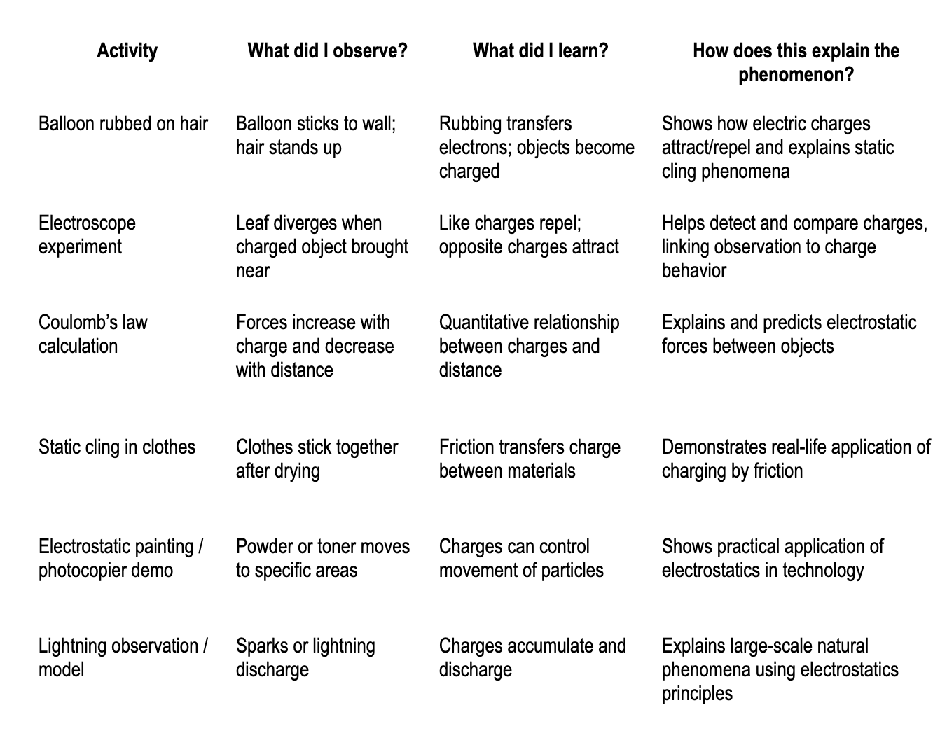 | -Students justify in writing how each activity (e.g., balloon demo, electroscope, Coulomb’s law calculations) contributes to their explanation of the phenomenon.  -They also identify gaps in their understanding which still need evidence. | -Teacher checks alignment between students’ observations, claims, and explanations.  -Written feedback is provided on whether the reasoning is specific, accurate, and linked to evidence.
- FINAL EXPLANATION:  What will students be able to explain when they are finished with the Unit/Chapter?  Expectation for the final explanation: (citing evidence gathered that helps explain the scientific principles for this chapter/unit)?  Write out the final explanation here.  - Uses scientifically accurate and grade- appropriate scientific information to explain the phenomena | Revisit the Driving questions to identify what evidence students have gathered to help them answer the questions.  -Khan Academy Coulomb’s Law video (concept and problem examples).  -Students’ own completed summary tables and revised models.  -PhET simulation screenshots and lab notebooks. | What is the plan for helping students write this final explanation? (Use their final Model. Summary Table.)  State the phenomenon.  List the evidence gathered (demos, PhET, experiments, calculations).  Explain with scientific principles (charge, conservation, Coulomb’s law, induction).  Link to real-world applications (photocopier, spray painting, lightning protection). | -A rubric with four criteria: Accuracy, Use of Evidence, Application to real life, and Coherence.  -Peer and teacher feedback sessions are done before the final submission to ensure learners can refine and improve their explanations.

CBE REQUIREMENTS REFERENCED IN THIS UNIT | Clearly articulate how these topics are addressed in this unit
Core competencies* (digital literacy, citizenship, learning to learn, collaboration/communication, critical thinking/problem solving, self-efficacy, imagination/creativity) addressed in this Curriculum Design | Core Competencies addressed:  - Communication and Collaboration: Learners work in groups during experiments, share observations, and co-construct models on the Driving Question Board.  - Critical Thinking and Problem Solving: Learners analyze experimental data, identify patterns in charge interactions, and apply Coulomb’s law to solve numerical problems.  - Creativity and Innovation: Learners design and propose simple electrostatic devices (e.g., using a homemade electroscope to detect charges).  - Digital Literacy: Learners interact with PhET simulations and online videos to visualize invisible phenomena like charge distribution.  - Learning to Learn: Learners reflect after each activity in the summary table and update their models, developing metacognitive skills.  - Citizenship: Learners discuss safety practices during thunderstorms (lightning protection), linking science to responsible action in the community.  - Self-efficacy: Repeated practice and successful demonstrations help learners gain confidence in their ability to explain abstract concepts like electrostatics.
Which Core Values** are addressed? (Nationalism and patriotism, Respect, Responsitillity, Integrity, Peace and Social Justice, Love, Unity, Excellence, Care and Compassion, Tolerance, Ethics) (do this by using Norms?) | Core Values addressed:  - Responsibility: Learners handle electrical and laboratory equipment carefully and safely.  - Respect: Learners respect one another’s ideas during group discussions and peer feedback activities.  - Integrity: Emphasis on honest reporting of observations and experimental results.  - Excellence: Learners strive to make accurate measurements, correct calculations, and clear explanations.  - Unity and Love: Learners work together in mixed groups, supporting weaker students and fostering a caring learning environment.  - Peace and Social Justice: Discussions on safety and fair access to science applications (e.g., lightning protection in schools and communities).
Which pertinent and contemporary issues are/ or could be addressed in this scheme of work? | Pertinent & Contemporary Issues (PCIs):  - Environmental Conservation: Use of electrostatics in pollution control (electrostatic precipitators reduce smoke particles).  - Safety: Awareness of lightning hazards in Kenyan schools and rural communities.  - Technology: Applications such as spray painting, photocopiers, and laser printers.  - Health: Understanding static discharge in hospitals and industries where sparks could ignite flammable gases.
Are there careers that might use this knowledge | Careers linked to this knowledge:  - Electrical engineering (design of appliances, circuits).  - Meteorology (study of lightning and weather phenomena).  - Electronics repair and maintenance.  - Printing and photocopying industry.  - Automotive industry (electrostatic spray painting).  - Safety engineering (fire prevention in fuel depots and factories).
Do we need to create Rubrics for any of the embedded assessments? If so list those here: | Rubrics needed:  - Model Drawing Rubric: Criteria for accuracy of labeling, correct use of arrows, and scientific explanation.  - Summary Table Rubric: Criteria for clarity of observations, logical explanation, and link to the phenomenon.  - Final Explanation Rubric: Four categories – accuracy of science concepts, use of evidence, connection to real-life applications, and overall coherence.

*CORE COMPETENCIES:
- Communication and Collaboration:.
- Emphasizes the ability to effectively communicate ideas and work with others.
- Self-efficacy:.
- Focuses on building learners' confidence and belief in their ability to succeed.
- Critical Thinking and Problem Solving:.
- Encourages learners to analyze information, solve problems, and make informed decisions.
- Digital Literacy:.
- Develops the skills to effectively and safely use technology and digital tools.
- Learning to Learn:.
- Fosters a mindset of continuous learning and the ability to acquire new knowledge and skills independently.
- Citizenship:.
- Promotes an understanding of civic responsibilities and active participation in society.
- Creativity and Innovation: .
- Encourages learners to think creatively, generate new ideas, and find innovative solutions.

**CORE VALUES:
- Nationalism and Patriotism: Instilling a sense of national unity, identity, and pride in Kenya.
- Respect: Fostering respect for oneself, others, and cultural diversity.
- Responsibility: Developing a sense of responsibility towards oneself, the community, and the environment.
- Integrity: Promoting honesty, ethical behavior, and moral principles.
- Peace and Social Justice: Encouraging harmonious coexistence and equitable treatment of all.
- Love: Creating a supportive and caring learning environment.
- Unity: Promoting togetherness and social cohesion.
- Excellence: Striving for high standards in all endeavors.
- Care and Compassion: Developing empathy and concern for the well-being of others.
- Tolerance: Fostering understanding and acceptance of different perspectives.
- Ethics: Instilling a strong moral compass and ethical decision-making.

Activity | What did I observe? | What did I learn? | How does this explain the phenomenon?
Balloon rubbed on hair | Balloon sticks to wall; hair stands up | Rubbing transfers electrons; objects become charged | Shows how electric charges attract/repel and explains static cling phenomena
Electroscope experiment | Leaf diverges when charged object brought near | Like charges repel; opposite charges attract | Helps detect and compare charges, linking observation to charge behavior
Coulomb’s law calculation | Forces increase with charge and decrease with distance | Quantitative relationship between charges and distance | Explains and predicts electrostatic forces between objects
Static cling in clothes | Clothes stick together after drying | Friction transfers charge between materials | Demonstrates real-life application of charging by friction
Electrostatic painting / photocopier demo | Powder or toner moves to specific areas | Charges can control movement of particles | Shows practical application of electrostatics in technology
Lightning observation / model | Sparks or lightning discharge | Charges accumulate and discharge | Explains large-scale natural phenomena using electrostatics principles

